|  |  |
| --- | --- |
|  | **DEPARTMENT OF COMPUTER SCIENCE AND ENGINEERING**  **PES UNIVERSITY**  (Established under Karnataka Act No. 16 of 2013)  100 Feet Ring Road, Bengaluru – 560 085, Karnataka, India |

**Guidelines to use JIRA for SWE Project**

**INTRODUCTION**

**JIRA** is a tool developed by Australian Company Atlassian. This software is used for **bug tracking, issue tracking,** and **project management**.

**Jira** is an all-in-one solution for multiple software and team related use cases:

* **Creating Backlogs**
* **Creating Sprints**
* **Creating Tasks**
* **Updating status on the board**
* **Managing release**
* **Code Integration**
* **Managing workflows**

**How to Use JIRA?**

##### Log into <https://id.atlassian.com/> using your gmail account or create an Atlassian account and follow these steps.

1. Open Jira software and navigate to the Jira Home icon
2. Select Create project option
3. Choose **Scrum** template from the listed Project templates
4. Choose **Team-managed project** for the project type.
5. Specify project Name and create the project without changing any other default values.
6. Select **Create** at the top of the dashboard and create one or more issues by creating one story at a time.
7. Invite your Team members and start working (Click on **People** tab at the top of the dashboard, select **Invite a teammate** and enter email ids of your team members)
8. Outside Jira software, create a csv file with bugs/issues encountered in your project using the template “**sample_jira_bug_template**” provided to you. If you did not encounter any bug in your project go ahead and still add some issues seen during the project as per the format provided in sample_jira_bug_template.
9. Open the issue(s) created before, add appropriate comments once the issue is resolved or completed and mark the status to **DONE** using **To-Do** drop down list.
10. On the left panel of your project dashboard, select **Project settings** and then **Issue types**
11. On the left panel of **Issue types**, select **Epic**, **Bug**, **Story**, **Task** or **Subtask** and populate the appropriate fields for each one of issue types on the right as per your project requirements.
12. Select your Project, open **Create issue** pop-up by clicking **Create** button at the top and import the csv file you had created earlier by selecting the button **Import issues**
13. Use all default values while importing the csv file.
14. Set JIRA field = Summary in the **Map fields** page, check the **Map field value** checkbox and click **Next**
15. Validate the imported map values and select **Begin Import**
16. At the end of the project, ensure all the issue(s) are resolved (by setting every issue to **DONE**) and export the issue(s) to **Word format** by clicking on “**...**” followed by “**Export Word**” as shown in the screenshot below

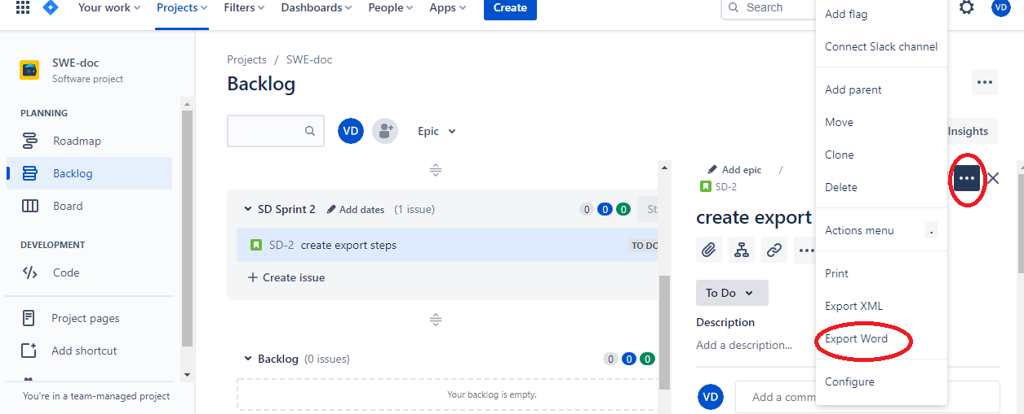

1. **Submit the word doc as per the submission instructions provided by your subject teacher for the purpose of evaluation**.

**Explore JIRA tool further**: (Evaluation/Marks for these tasks TBD)

1. Use **Bug tracking** template from the listed Project templates and create a Bug report using **Export Word** option like you did for the Scrum template before. Open the bug issue and resolve the bug by setting **Resolution** to **Done**
2. Create a sprint for the SCRUM project, define some stories, creating Epic stories and export Sprint report as well as Epic report.
3. Create a **Burndown Chart** for your Sprint. Make sure **Reports** is enabled in **Project Settings > Features** as shown below for this task.

**WHAT IS A BURNDOWN CHART?**

A burndown chart shows the amount of work that has been completed in an epic or sprint, and the total work remaining. Burndown charts are used to predict your team's likelihood of completing their work in the time available. They're also great for keeping the team aware of any scope creep that occurs. Burndown charts are useful because they provide insight into how the team works.

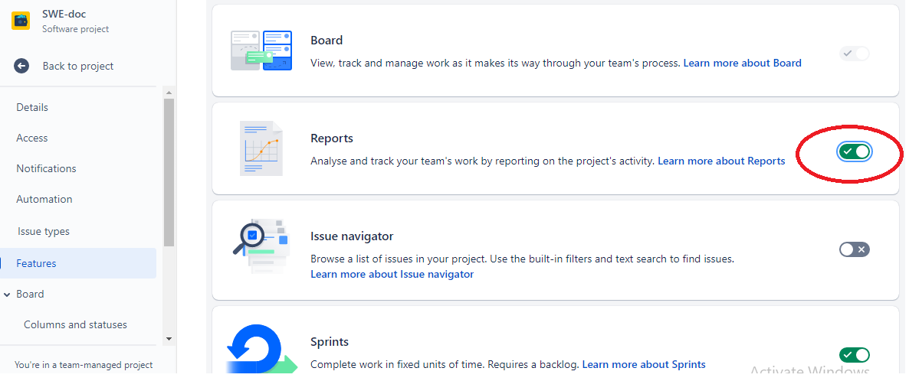

**References:**

<https://www.atlassian.com/software/jira>

<https://www.atlassian.com/agile/tutorials/burndown-charts>

<https://www.guru99.com/jira-tutorial-a-complete-guide-for-beginners.html>